**A**

**Project Report**

**On**

**INTERNSHIP IN IPHONE APP**

**DEVELOPMENT**

(CE346 – Summer Internship-1)



**Prepared by**

16CE068

**Under the Supervision of**

Neel Vegda

**Submitted to**

Charotar University of Science & Technology (CHARUSAT)

for the Partial Fulfillment of the Requirements for the

Degree of Bachelor of Technology (B.Tech.)

in Computer Engineering (CE)

for 5th semester B.Tech

**Submitted at**



**Accredited with Grade A by NAAC**

**Accredited with Grade A by KCG**



**U & P U. PATEL DEPARTMENT OF COMPUTER ENGINEERING**

**(NBA Accredited)**

**Chandubhai S. Patel Institute of Technology (CSPIT)**

**Faculty of Technology & Engineering (FTE), CHARUSAT**

**At: Changa, Dist: Anand, Pin: 388421.**

**June, 2018**

**DECLARATION BY THE CANDIDATE**

I hereby declare that the project report entitled “**iphone app development**” submitted by me to Chandubhai S. Patel Institute of Technology, Changa in partial fulfilment of the requirement for the award of the degree of **B.Tech** in Computer Engineering, from U & P U. Patel Department of Computer Engineering, CSPIT/FTE, is a record of bonafide **CE346 Summer Intership-1** carried out by me under the guidance of **NEEL VEGDA**. I further declare that the work carried out and documented in this project report has not been submitted anywhere else either in part or in full and it is the original work, for the award of any other degree or diploma in this institute or any other institute or university.

16CE068

NILESH DUBEY

Assistant Professor



**Accredited with Grade A by NAAC**

**Accredited with Grade A by KCG**

**CERTIFICATE**

This is to certify that the report entitled “**iphone app development**” is a bonafied work carried out by **16CE068** under the guidance and supervision of **Neel Vegda** for the subject **Summer Intership-1 (CE346)** of 5th Semester of Bachelor of Technology in **Computer Engineering** at Chandubhai S. Patel Institute of Technology (CSPIT), Faculty of Technology & Engineering (FTE) – CHARUSAT, Gujarat.

To the best of my knowledge and belief, this work embodies the work of candidate himself, has duly been completed, and fulfills the requirement of the ordinance relating to the B.Tech. Degree of the University and is up to the standard in respect of content, presentation and language for being referred by the examiner(s).

|  |  |
| --- | --- |
| Internal Guide,  Nilesh kumar dubey  Assistant Professor,  U & P U Patel Department of Computer Engineering | External Guide,  Neel Vegda  Employee  Kals infotech |
| Dr. (Prof.) Amit Ganatra  Head - U & P U. Patel Department of Computer Engineering,  Dean - Faculty of Technology & Engineering (FTE),  CHARUSAT, Changa, Gujarat. | |

**Chandubhai S. Patel Institute of Technology (CSPIT)**

**Faculty of Technology & Engineering (FTE), CHARUSAT**

At: Changa, Ta. Petlad, Dist. Anand, Pin:388421. Gujarat.

**ABSTRACT**

In this report I have described my learning experience of ios app development in kals infotech and also described about my work and app made by me during training. The app has many small basic functions like login, calculator , camera, sql in iphone, mapkit , gestures ,video player, music player.

The iPhone has become a top selling smartphone since its launch in 2007 and has along with its iOS (Apple's mobile operating system) overtaken many popular and established mobile phone brands in the ratings. Some competitors have not been able to provide a competing smartphone while others have grouped together to withstand the Apple onslaught.

**ACKNOWLEGEMENT**

With immense pleasure, I would like to present this project report on Iphone app Development, “A Study on Iphone apps analysis ”, Nadiad located in Kheda district, Gujarat. It has been an enriching experience for me to undergo my summer training at KALS Infotech, which would not have possible without the goodwill and support of the people around.

As a student of CSPIT, I am highly thankful to **Nilesh Dubey** who allowed me for this project at KALS Infotech. I would like to give my heartily thanks to Neel Vegda who guided me and support throughout the project. Without them I would not be able to complete this project successfully. I am very thankful to whole staff who helped me at every step whenever needed.

I sincerely thanks to my faculty guide Nilesh dubey,for providing understanding on the ways of preparing a project report and for the guidance and support for Summer Training.

Lastly, I convey my regards to the whole staff, which made my stay at KALS Infotech, a memorandum part of life.

**Table of Contents**

|  |  |
| --- | --- |
| **Chapter**  **No.** | **Title** |
|  | **PART I – COMPANY PROFILE** |
| **1** | Introduction |
| **2** | The Company / Organization   * Evolution and History * Mission and Vision * Governance / Management Structure * Products * Geographical Spread of facilities |
| **3** | Tasks and Activities performed at the organization |
| **4** | Learning Experience (Novelty and originality of works) |
|  | **PART – II – PROJECT STUDY** |
| **5** | Overview of the Project   * Background of the study * Importance of the study to the organization * Objectives of the study * Tools and Technology description * System Flow chart * Screenshots |
| **6** | Conclusions and Limitations |
| **7** | Applications |
| **8** | References |
| **9** | Appendices |

**COMPANY PROFILE**

* Introduction

The collaborative process of web & Mobile Application development requires close integration of technology and design. Kals infotech easily and efficiently scales your project with one code base. Amazing solution for portfolio websites which you can fit for freelancers, photographers or agency showcase. We are here for web development,design and mobile application related services. We provide best services ever with client's requirements.We can also provide solutions of your websites and other applications. Kals infotech is develop creative ideas for your next project! It’s time to grow your business. Go make something awesome. Designed for Everyone. Let’s give your website a brand.

* The Company / Organization
* Evolution and History

Company is made by student passed from cspit and is startup.

* Mission and Vision

Self motivate,Think beyond,work hard for knowlrdge and use it to implement yourself.

* Governance / Management Structure

Neel vegda-co founder

Sagar sakhiya-director

Jatin kavani-web designer

Patel bhavik-co worker

Shubham khatri-worker

* Products

Average Calculator Average calculator apps is basically calculate average of bikes,cars, and any vehicles based on data provided by user and it gives user an accurate average.

 app for finding place near by u

now we came with our new application, build your body like a superstar. Explore your style, [#fitnesshunter](https://www.facebook.com/hashtag/fitnesshunter?source=feed_text)

WhatsappGroupLink  With this application you can expand your business,friends groups. You can also get different types of study materials according to your education. Also give us review.

* Geographical Spread of facilities

 TF-28,BAKROL SQUARE,VALLBH VIDHYA NAGAR,ANAND 388120

* Tasks and Activities performed at the organization

Studied ios programming and learnt using xcode.

15-may:started internship in ios development in kals infotech.learned basic and platform.

16-may:Downloaded xcode 9.3.4 and created first layout storyboard and played.

17-may:made login page with some restrictions and storyboard.

18-may:made wifi hotspot login app and saved username password in database.

19-may:created calculator app with factorial finding and square root.

20-may:learnt table view and created tableview chat app with additional feature of users

21-may:learnt collection view and cells.made collection view app.

22-may:learnt to make camera app to check photos.

23-may:learnt to select photo from photo library.

24-may:learnt scroll view and managing it.made excel like app using scroll view.

25-may:learnt action sheet and pop overs. Made changes in camera app.

26-may:holiday

27-may:holiday

28-may:learn gesture managing and accelerometer managing

29-may:learnt tab view controller.

30-may:learnt sql with fmdb and made small app to save data in database.

31-may:displaying database in table.

1-jun:made sql lite database and displaying database.

2-jun:holiday

3-jun:holiday

4-jun:learnt mapkit and made user location finding app.

5-jun:learnt annotations and putting pin on map by clicking on map.

6-jun:made settings of map.

7-jun:made page control app

8-jun:made page controls app using default page controller.

9-jun:holiday

10-jun:holiday

11-jun:tab page menu control.

12-jun:music and audio player app.

13-jun:video player app.

14-jun:search bar in audio and video player.

15-jun:made menu control for home page.

* Learning experience

**New and improved skills and how to apply them**

One of the most important things you can gain from an internship is newfound knowledge. This can include knowing how to fulfil tasks that are relevant to your desired career path and sharpening the skills that you already possess.Many students think an internship mainly consists of making coffee and running errands for superiors all day, but that is not true. And really, it shouldn’t be like that. An internship is an opportunity to test out all the skills that you developed in varsity/college and see how they work in the real world.

**Professional communications**

Working in a professional setting for the first time can be difficult to get used to. But it is the best way to learn how to navigate the working world through real-life, hands-on experience.

One of the most valuable skills you will gain from an internship is the ability to speak with people in a professional setting. Discussions with bosses or coworkers are different from discussions with lecturers or fellow students,

After your internship, you should have a better idea of the appropriate way to behave as a professional. This will help you a lot when you start interviewing for jobs because you will be more confident and will sound more mature and experienced in a business setting.

**Networking is important**

Don’t underestimate yourself; make sure you make the most of your internship and take advantage of all the opportunities that come with it.

Also, unglue yourself from your desk every once in awhile and get to know other interns. Not only will you end up creating great memories and making friends, but you will widen your professional network.

Be proactive, and if you are invited to work functions introduce yourself to people.

This is the only way people will know who you are and what you’re all about and most importantly – remember you.

**Taking constructive criticism well**

Naturally, no one likes to be criticised and performance evaluations can be quite scary. You will probably make a few mistakes and receive constructive criticism about your work from both your colleagues and your boss.

Always remind yourself that it’s not personal. It is for your own good and growth and it will improve the quality of your work.

**Work hard no matter what you’re doing**

Always work hard even if your task is small and seems unimportant. It will help you build a good work ethic, and people will notice the effort you put in.It’s not nice being told what to do all the time, but your superiors (mostly) know better. Following the rules and instructions they give you makes it easier for everyone.

**Independence**

Often, we think being spoon-fed is the way to learn, but working independently has proved to be very important. Your internship will teach you to make my own decisions and do things on your own.

Being able to work independently with little guidance is very important in the working world.

**Making connections**

In addition to the people who will be your references in the future, try to leave your internship with new connections: senior employees, clients, fellow interns, etc.These people can provide guidance, advice and help you in future job searches. Keep them in the loop on where you are in your career, and offer to help them whenever you can.To do this, you’ll need to make an effort during the course of your internship to build relationships with people around the office.

**You’re more important than you think**

Even though you are at the bottom of the career ladder, you’re also needed and your basic work is appreciated.

Intern life can be tough, and you only get a short time to make a lasting impression. However, it is a great opportunity to gain experience, make friendships and learn. So work hard and enjoy your internship!

**PART – II – PROJECT STUDY**

Overview of the Project

* Background of the study

Technology is rapidly advancing and progressing! Computers have developed well beyond their beginning. Along with the computers come the developers and different companies who compete to have the best products and most useful software! These companies have different names and their products have different features and capabilities. Apple is one of the most popular electronic device producers today. They earned their credibility by developing some of the best devices with very reliable and useful software. According to Forbes Magazine on August 21st, 2012 Apple made history by becoming the most valuable company in history, beating out the previous champs Microsoft. They first started with the Macintosh computer which ran on Mac OS. The Macintosh computer was so popular because of the graphical user interface or GUI. The GUI is the part of the computer that people, or users, actually see. Over time the Macintosh evolved into the Mac running on OS X. Along with Apple’s evolving is the progressing of their mobile devices. They made their debut in 2007 releasing the iPhone which was the only touchscreen smartphone on the market. The iPhone ran on iOS which has developed over time, for example: iOS 3, iOS 4, iOS 4.1 etc. This operating system was designed for their different mobile devices. Apple specifically designed this system so that it is easy to use and compatible the devices. Their easy-to-use mobile systems began with four iOS layers. The thing that really makes Apple’s devices the best are the operating systems which support them.   
The operating system Apple uses for their mobile devices is iOS. This iOS software is made up of four main layers: the Cocoa touch layer, the Media layer, the Core Services layer and Core OS layer. Within each of these layers are many different frameworks that all carry out different jobs to help the user have a pleasant experience. The cocoa touch layer is the highest layer amongst the four. It is responsible for providing the core functionalities for your applications, or apps for short. The next layer is the media layer. This is where the system is provided with audio, video and graphics capability. The core services layer basically provides the foundation for the cocoa touch and media layers. Last but not least is the core layer. It’s at the bottom of the stack and provides low-level networking, memory management and access for external accessories because it is in physical contact with the device hardware.

According to market share reports from the first quarter of 2011 (Flores, 2011), Apple has surpassed Nokia and taken the number one spot on the European charts with just over 20 percent. This is counting smartphones only, since Apple only sells the iPhone. The chart supplying these numbers compares smartphone developers. Another popular comparison seen in a lot of charts is categorizing and comparing the number of smartphones sold by their software platforms. On this list, Android OS has the largest market share worldwide followed by Symbian, an OS maintained mainly by Nokia (Savov, 2011). Apple iOS places third on this list. What is very important to remember is that iOS is unique to Apple devices - the iPod touch, iPhone and iPad - while Android and Symbian can be found on a multitude of different smartphones. This means that while iOS is not the leading mobile operating system, the iPhone still outsells each individual smartphone equipped with Android or Symbian (Dalrymple, 2011). Since its release in 2007, the iPhone has obviously become very popular. That may be thanks to a large Apple fan base, clever marketing, the revolutionary touch display or maybe a mix of them all. All of these reasons and probably many more all add to the fact that Apple has become a prominent telephone developer with only one telephone, and a quite high-end one at that, on the market. Some giants in the industry like Nokia or Ericsson that have been around for over 50 years and have a large series of telephones, both smartand feature phones1 , on the market, now have to play catch-up with Apple to stay in the race for the smartphone market. But that is not to say Apple hasn't had any obstacles in their way. One topic of discussion has been the fact that the iPhone lacks a physical keyboard or numpad. One article (Senia, 2007) describes a disappointed audience which noted that writing an SMS took twice as long on the iPhone compared to their normal regular input telephone. Another topic of discussion was the fact that the iPhone 1 lacked 3G support. Apple defended themselves with the fact that the 3G technology was still underdeveloped and caused a serious drain on the battery. 3G was implemented a year later with the iPhone 3G. There were also speculations

* Importance of the study to the organization

**Salaries** – The average salary of the iOS Developer is 30% higher than web developers (source: Payscale). This is due to low supply and high demand of iOS Developers in Malaysia. iOS Developers are also in high-demand across ASEAN countries, so you can be sure this can be a useful skill to have.

iOS also has a mature, more stable**Integrated Development Environment (IDE) for development** than the Android platform. This environment is known as Xcode and lets you develop iPhone, iPad, Mac OSX, and iWatch applications all in one place. It has many important features such as  Code Completion, its UI design interface, managing directories’ hierarchy, profiling, debugging, core data, assets management, and many more.

**Apple users spend more money on the app store** than Android users. This means, the apps you develop on the iOS platform has the potential to make more revenue (through ads/in-app purchases) than Android apps.

**Compatibility issues.** There are so many different mobile devices which run the Android operating system… Making apps for Android can sometimes be a bit of a nightmare. Whereas for iOS, they tend to maintain compatibility between devices so you can develop iOS apps for one version and easily update them for the next.

* Objectives of the study

To learn objective c and making independent apps.

* Learning experience

Before I had any idea how iPhone apps are actually developed, what coding language is used etcetera, I thought my background in website development would help me. I was pretty wrong. Apps are first of all software, not web applications, meaning it's developed in an entirely different coding language and practice from what I'm used to. There are things such as memory handling and more complex variable defining 8 compared to web languages. Although knowing any code language will of course lessen the challenge of learning another, I had to face quite a steep learning curve the first couple of weeks. For reference, iOS development is done in Apple's developer tool Xcode. The coding language is called Cocoa, which is an extension of Objective-C, which in turn is an extension of C. As the days passed and things started making sense, I started learning quite a lot about how apps are made, and why a lot of them seem to look the same.

* Tools and Technology description

Xcode is the **Integrated Development Environment** (**IDE**) provided by Apple to third-party programmers such as yourself for developing iOS and OS X applications written in Objective-C and Swift. An IDE is a program (or program suite) that incorporates tools for the various aspects of creating software. Xcode, specifically, brings together the code editor, compiler, debugger, interface builder, application bundler, and simulator (which is technically a separate program launched from within Xcode).

1. **Code Editor** - a text editor that specializes in handling code as text. Sublime Text is a prime example of a standalone code editor.
2. **Compiler** - this is a program that translates your code from Objective-C or Swift into machine language, the native language of the processor. When you hit "Run", your code is first compiled so it can then be handed to your computer's processor to execute. Xcode also contains a **Pre-Compiler** which scans your code *as you type it* for syntactical errors and other problems to reduce the likelihood that your build contains code that will cause a crash.
3. **Debugger** - all code has errors. "Good Practice" guidelines and pre-compilers help reduce the likelihood of errors being written, but they happen. Good debugging tools allow the programmer to scan the code as processes are running, watching the application's elements act upon and change themselves to see where they collide.
4. **Interface Builder** - specifically in Xcode this is the name of the suite that allows the use of Storyboards to create the visual layout of a user interface (UI) in a similar fashion to design and layout software.
5. **Application Bundler** - this assembles the program as an application package to be shipped to the consumer for deployment. You won't be using this for any of the labs, but you should know that Xcode contains the functionality to submit your application to the App Store for review. You might eventually do this on your own with side projects.
6. **Simulator** - Xcode contains a program for partially replicating the conditions of running your application on a mobile device. It's very useful for development to see how your code might behave once it's deployed, but for a variety of reasons it can't ever be quite the real thing so it can't replace testing your build on an actual mobile device.

The Xcode IDE is at the center of the Apple development experience. Tightly integrated with the Cocoa and Cocoa Touch frameworks, Xcode is an incredibly productive environment for building apps for Mac, iPhone, iPad, Apple Watch, and Apple TV.

#### Xcode smoothly takes you from concept, to code, to customers.

Because everything is so well integrated, workflows feel natural. As you compose a new interface, the Assistant editor intuitively presents the related source code in a split window pane. Simply drag the mouse to connect UI controls to the implementation code. Apple LLVM compiler technologies parse your code, keeping every symbol you see in the LLDB debugger consistent with the editor and compiler. As you type, that same engine is constantly at work, finding mistakes and offering Fix-its for your code.

Xcode even communicates with the Apple developer website, so you can enable services such as Game Center or Passbook in your app with a single click. When your app is ready, Xcode will bundle and submit your app to the App Store.

## **Assistant Editor**

## The Assistant button splits the Xcode editor in two, with your primary work document on the left and an intelligent Assistant editor pane to the right. The Assistant editor automatically displays files that Xcode determines are most helpful to you based on the work you are performing in the primary editor. For instance, if you are editing MyClass.m in the primary editor, the Assistant will automatically show the counterpart MyClass.h.

## **Jump Bar**

## Clicking the Jump Bar, located at the top of every editor pane, you can quickly select what information to view in the Assistant editor. For instance, while editing source code in the primary editor, the Assistant can show the counterpart header, sub-classes or superclasses, or related tests.

## **Interface Builder**

## Fully integrated within the Xcode IDE, the Interface Builder design canvas makes it simple to prototype a full user interface without writing any code. Prototype in minutes, then graphically connect your interface to the source within the Xcode editor, laying out windows, buttons, and sliders to create a functioning Mac, iPhone, or iPad user interface. With the Assistant editor, you can work on the graphical design side-by-side with the implementation source code. A simple mouse drag from a UI control to the source pane creates a connection between code and interface, and can even create the code stub for you.

## **Version Editor and Source Control**

The Version editor makes it easy to compare two versions of a file, see commit logs, check who made a code change, and even zoom back through the commit timeline. The Version editor splits the pane to show two different versions of the same file. Differences are highlighted as you travel through the timeline separating the editor views. Xcode can also create a local Git repository for new projects, or check out a hosted Subversion or Git repo. The top-level Source Control menu makes it easy to perform branch and merge operations, perfect for distributed teams.

## **Testing**

## Test-driven development is a first-class workflow within Xcode. The Test Navigator makes it incredibly easy to jump to any test in your project, execute an individual test, or execute a group of tests. The Assistant editor has new test-specific views that automatically track which tests exercise the code you are presently editing, keeping your tests and code in sync at all times.

## **Customize**

## The Xcode environment can be configured to match almost any workflow, including customization features like tabs, behaviors, and snippets.

## **Open Quickly**

Get quick access to any file your project uses with Open Quickly (Command-Shift-O). Xcode immediately offers completions for your search, allowing you to choose one and hit Return to open the file or hit Option-Return to open in the Assistant editor.

## **Schemes**

Customize the way Xcode builds and runs your app depending on whether you are debugging, profiling, performing code analysis, or running a test suite. For example, the default scheme is configured to build your app in “Debug” mode when running, and the same scheme settings will build for “Release” when performing the Profile or Archive command. There is no need to change project settings as you move from task to task. Xcode configures the schemes for you automatically, or you can use the “Manage Schemes” menu to customize them yourself.

* Screenshots

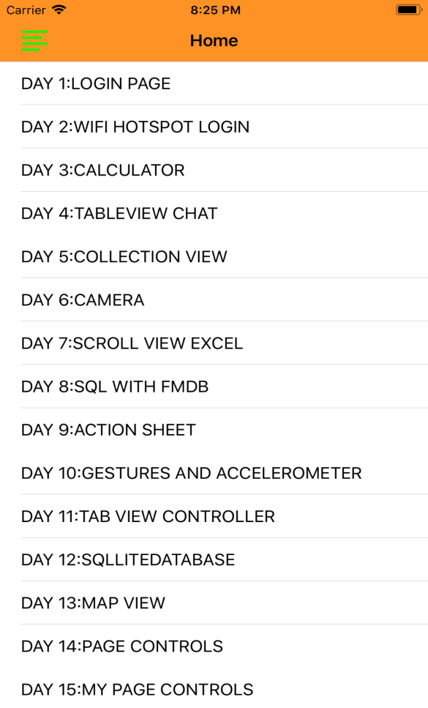 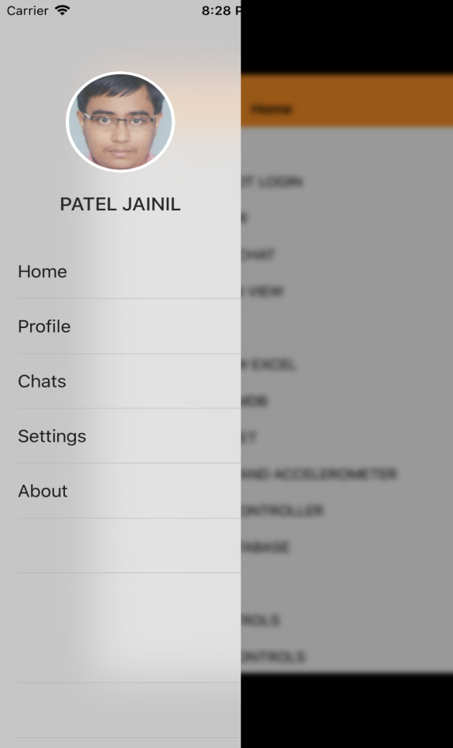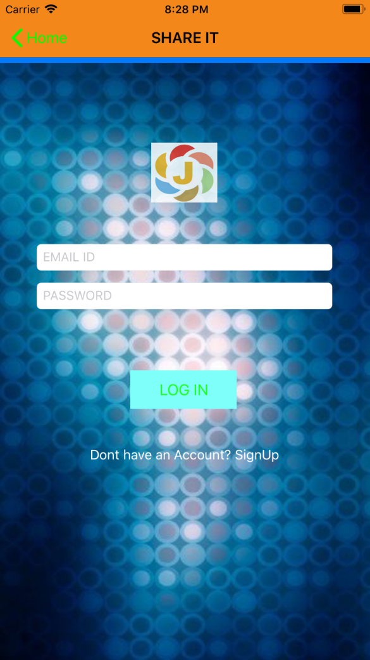 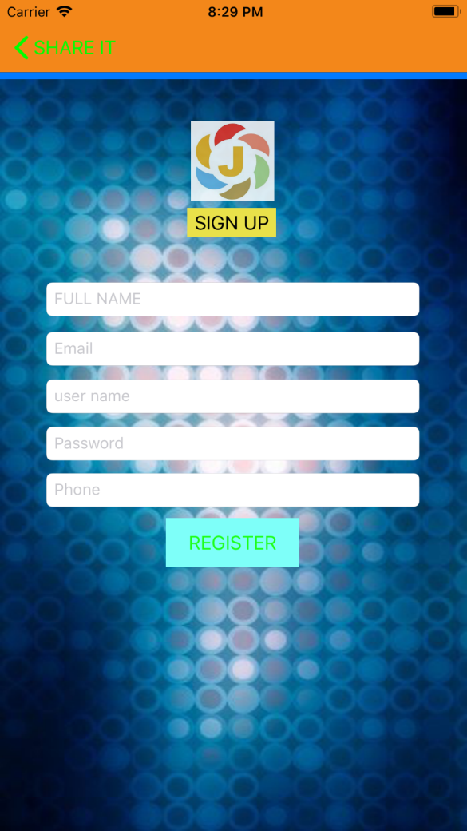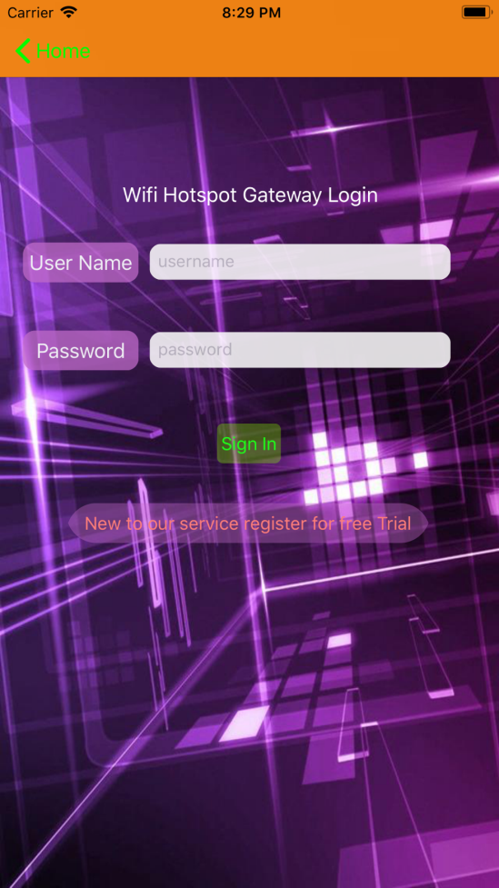 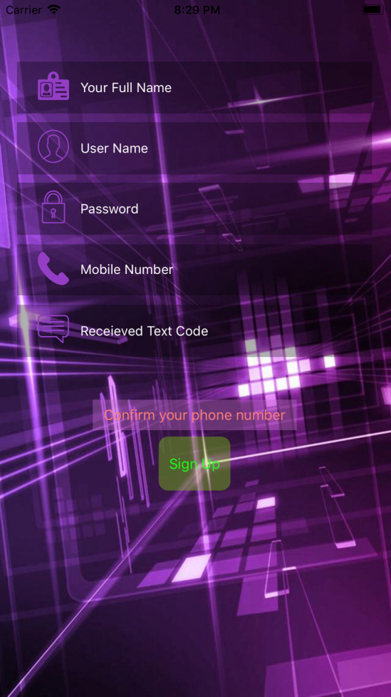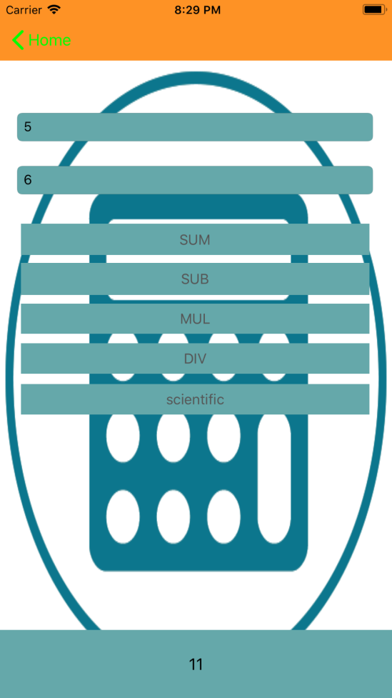 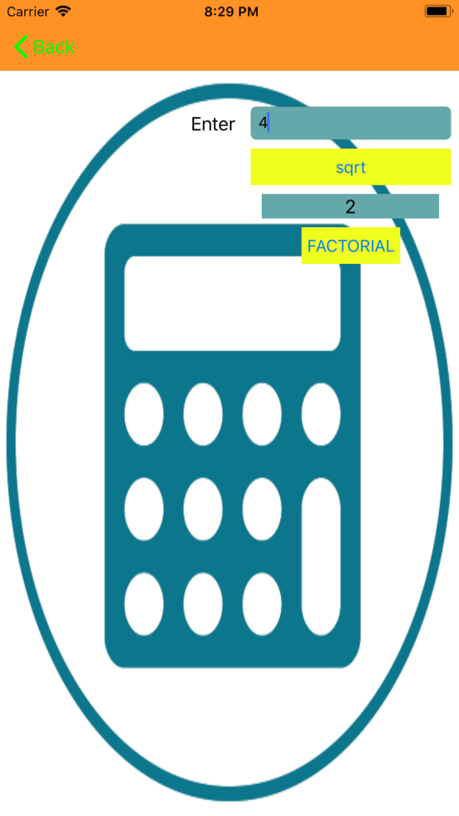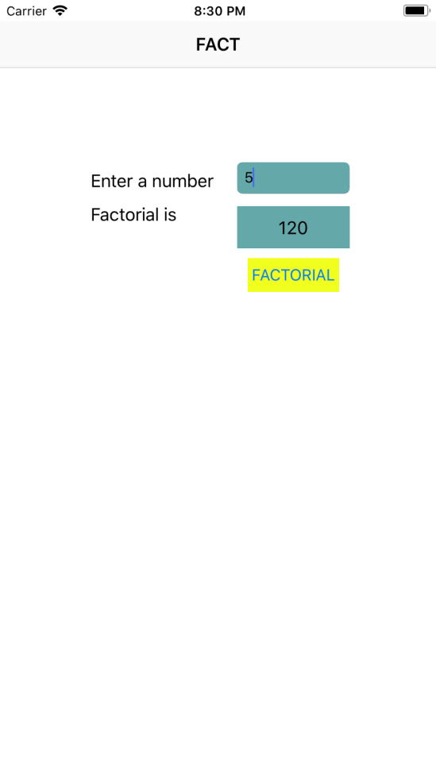 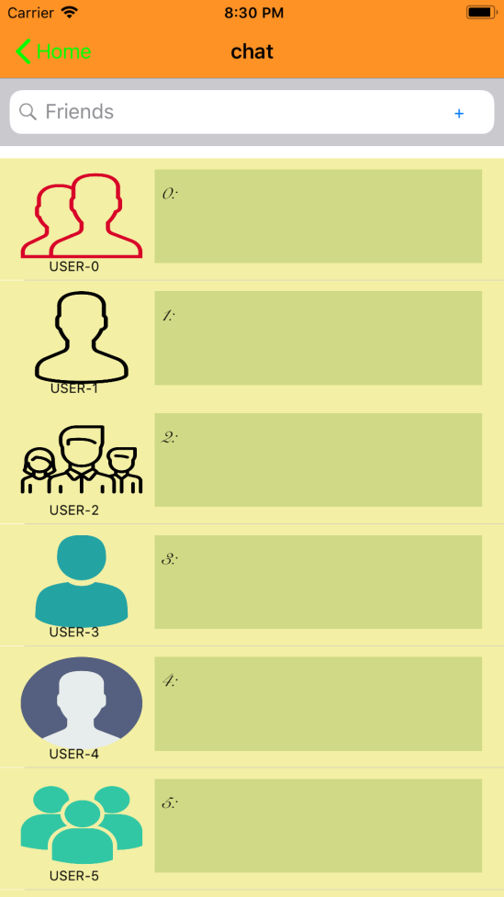 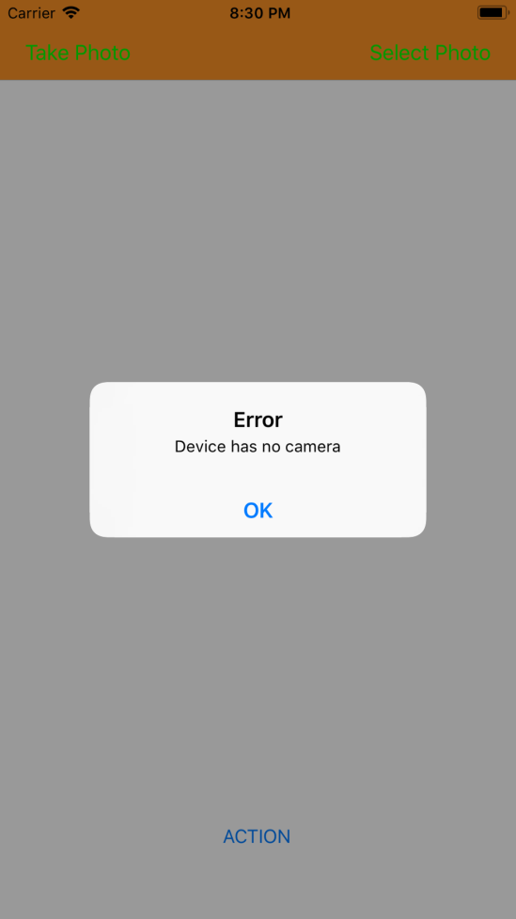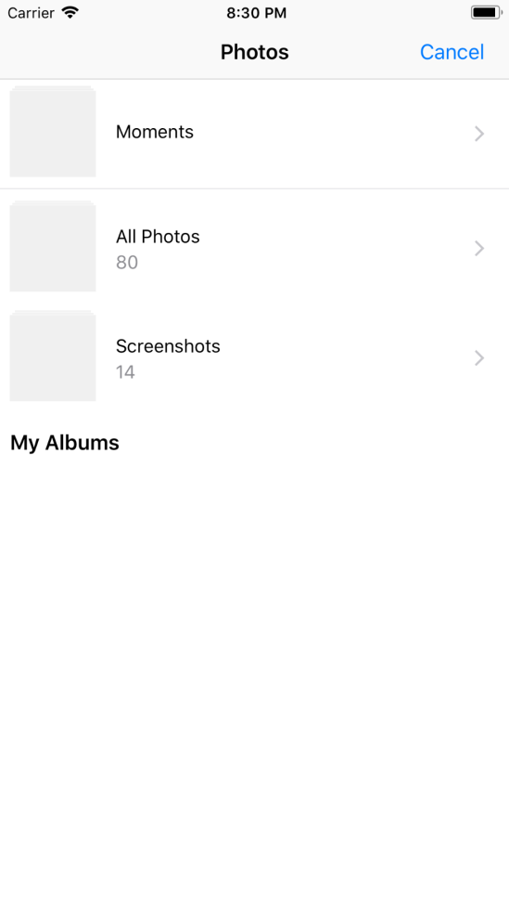 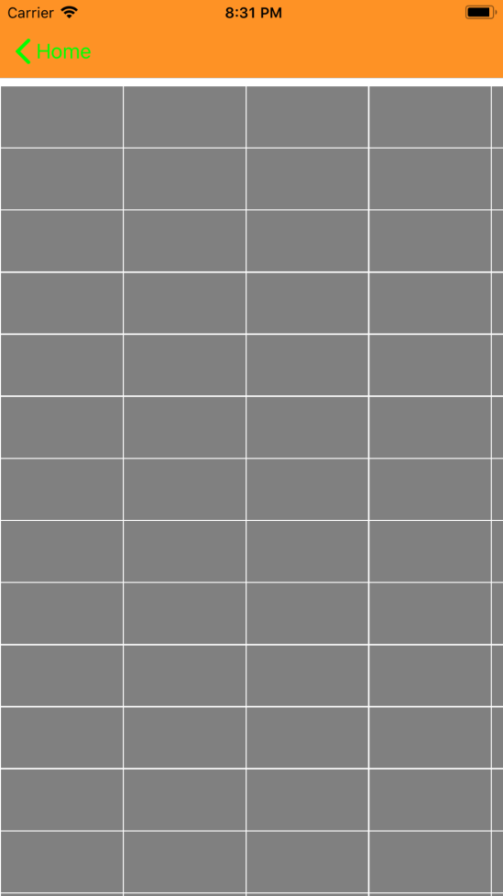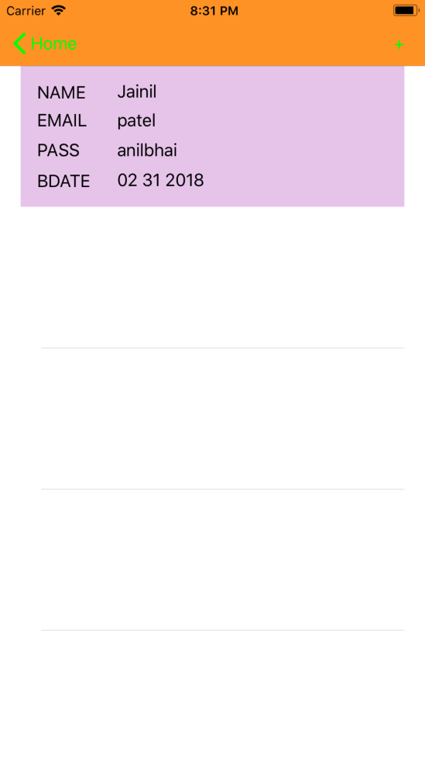 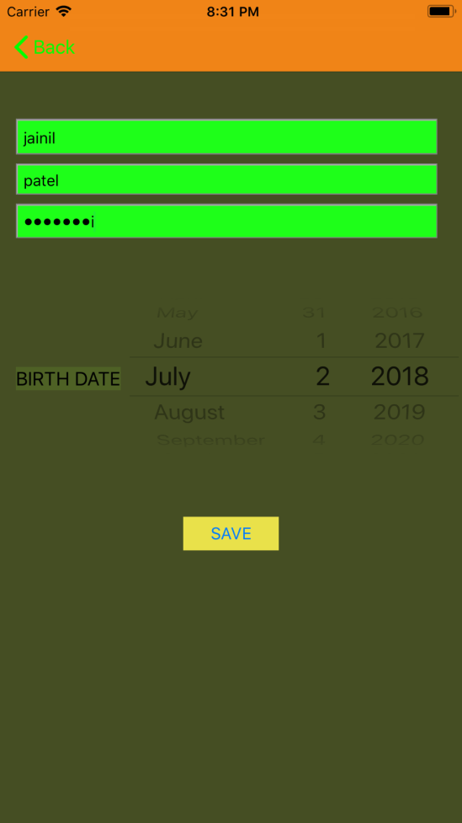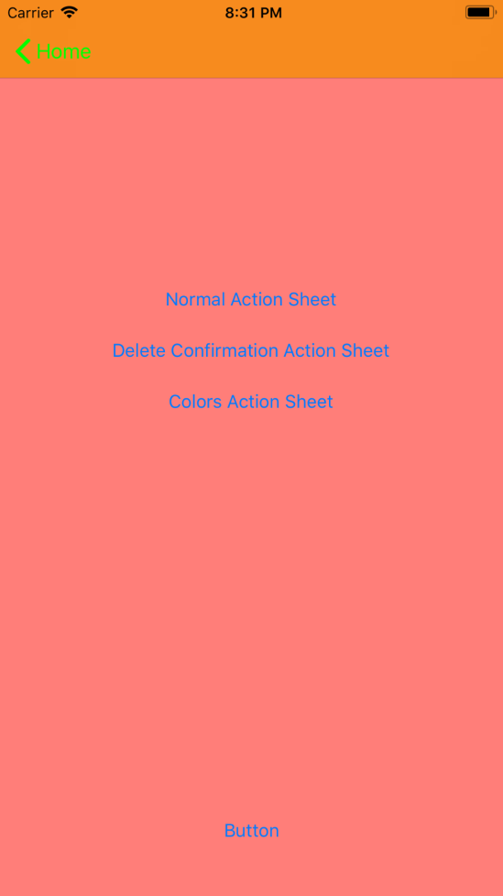 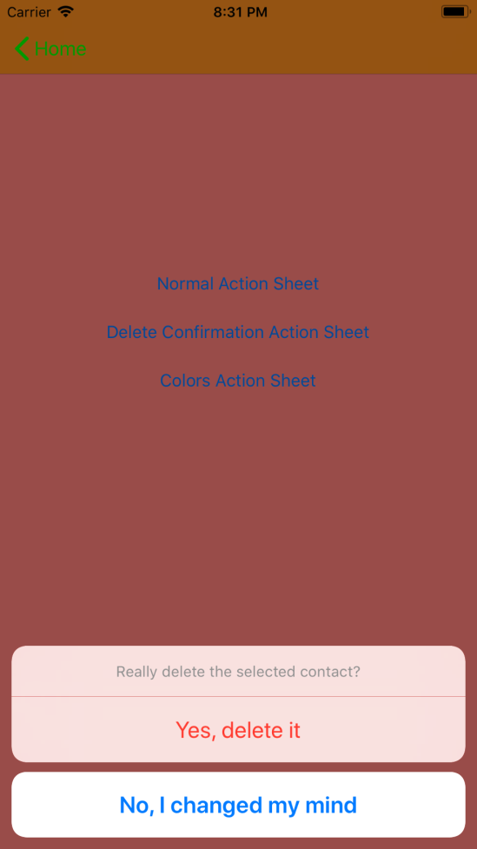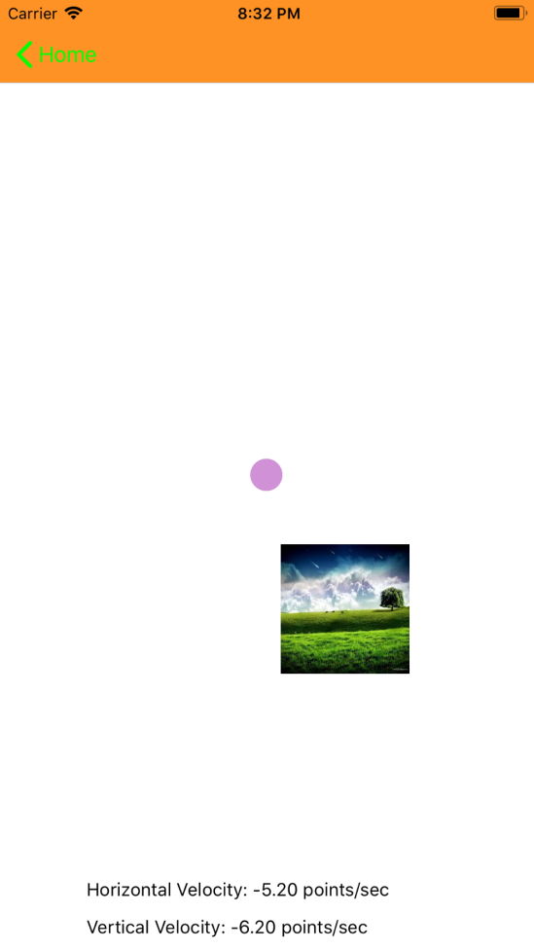 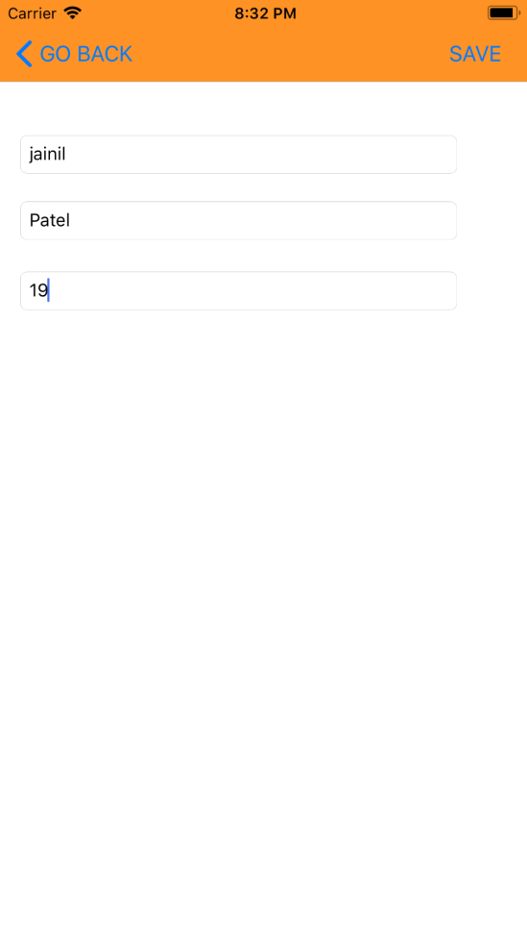 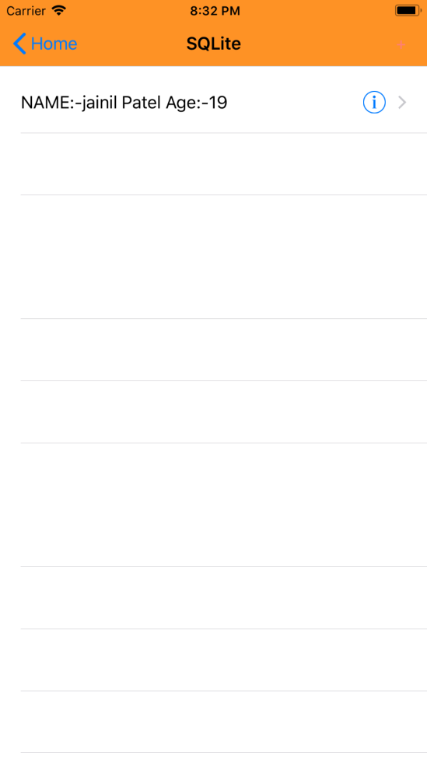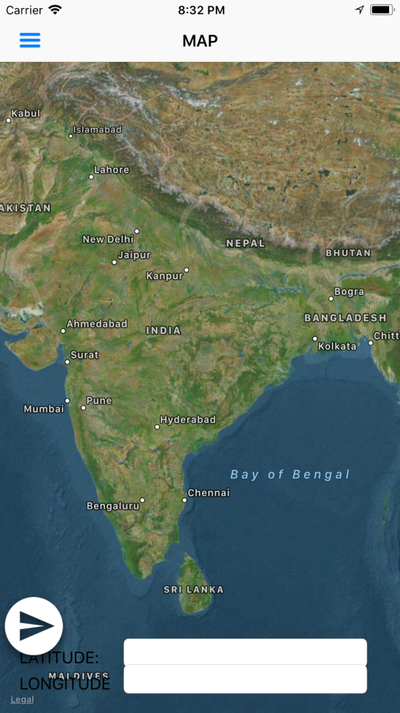 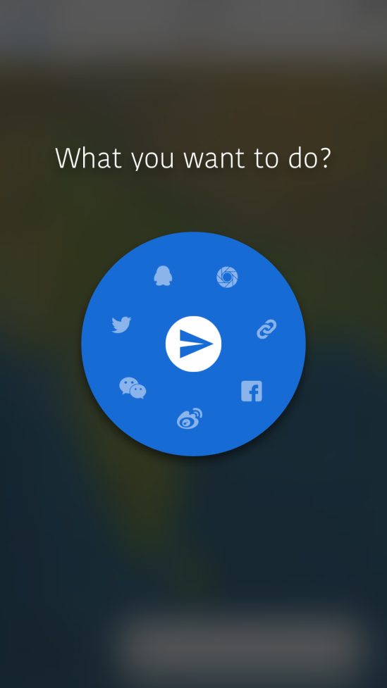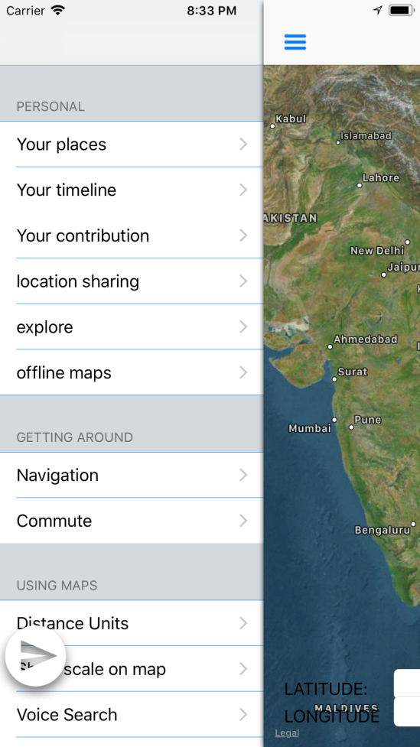  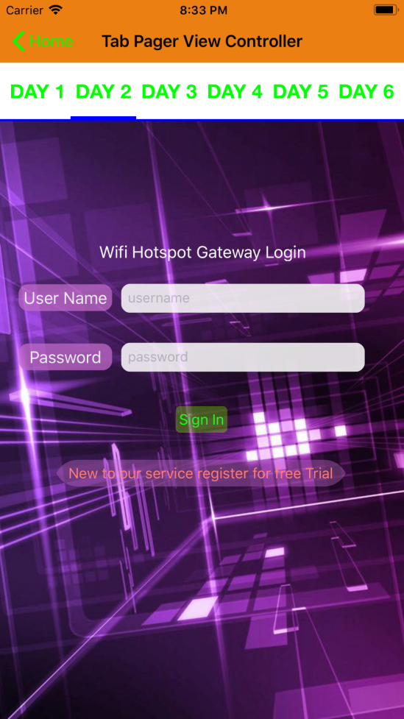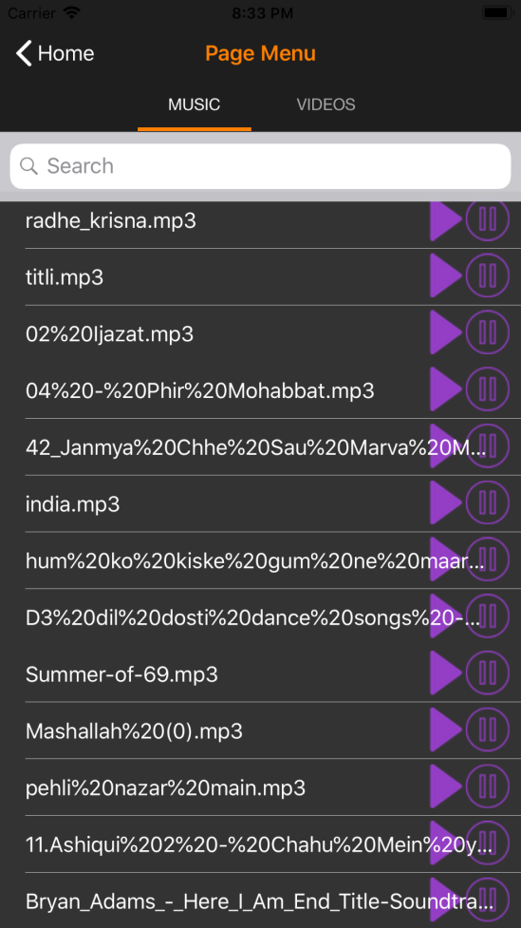 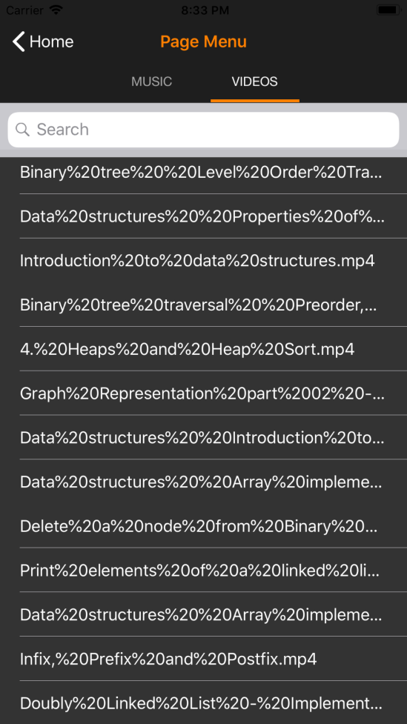

* Conclusions and Limitations

Learnt much more in industry and learned that they are constantly learning. Industry is advancing and we have to make our space in it. Learnt ios programming concepts and objective c from basics.

The app’s source code will help beginners to make apps. Industry demands new change.

* Applications

App can be used for maps, notes, music, video,etc.

* References

1) Programming IOS 8: Dive Deep Into Views, View Controllers, and Frameworks

2) Beginning IPhone Development: Exploring the IPhone SDK

3) Beginning IOS Programming For Dummies

WEBSITES

<https://stackoverflow.com/>

<https://www.tutorialspoint.com/ios/ios_objective_c.htm>

<https://www.appcoda.com/tag/objective-c/>

* **BIBILOGRAPHY**

1. **Programming IOS 8: Dive Deep Into Views, View Controllers, and Frameworks**
2. **Beginning IPhone Development: Exploring the IPhone SDK**
3. **Beginning IOS Programming For Dummies**

**WEBSITES**

[**https://stackoverflow.com/**](https://stackoverflow.com/)

[**https://www.tutorialspoint.com/ios/ios_objective_c.htm**](https://www.tutorialspoint.com/ios/ios_objective_c.htm)

[**https://www.appcoda.com/tag/objective-c/**](https://www.appcoda.com/tag/objective-c/)